PerformanceTestingPhase

Date | 2 November 2025
TeamID | NM2025TMlD03628
Projectname | Laptop Request Catalog Item

Introduction:

The Performance Testing phase of the Laptop Request Catalog Item Project using ServiceNow is conducted to ensure that the catalog item and its associated workflows operate efficiently under various load conditions. This phase focuses on evaluating the system’s speed, scalability, stability, and responsiveness when multiple users simultaneously submit or track laptop requests.

Purpose of Performance Testing:
The purpose of performance testing is to verify that the ServiceNow application:

• Measures the response time of the catalog item during laptop request submission and approval processes.

• Provides users with a smooth and responsive experience throughout the request process.
Objectives:

• To evaluate response time: Ensure that the laptop request form loads quickly and processes submissions without delays.

• To assess system stability: Verify that the catalog item performs consistently when multiple users access it simultaneously.

Testing Procedure:

• Document test results, identified issues, corrective actions taken, and final performance outcomes.

• Share the performance test report with the project team and stakeholders.

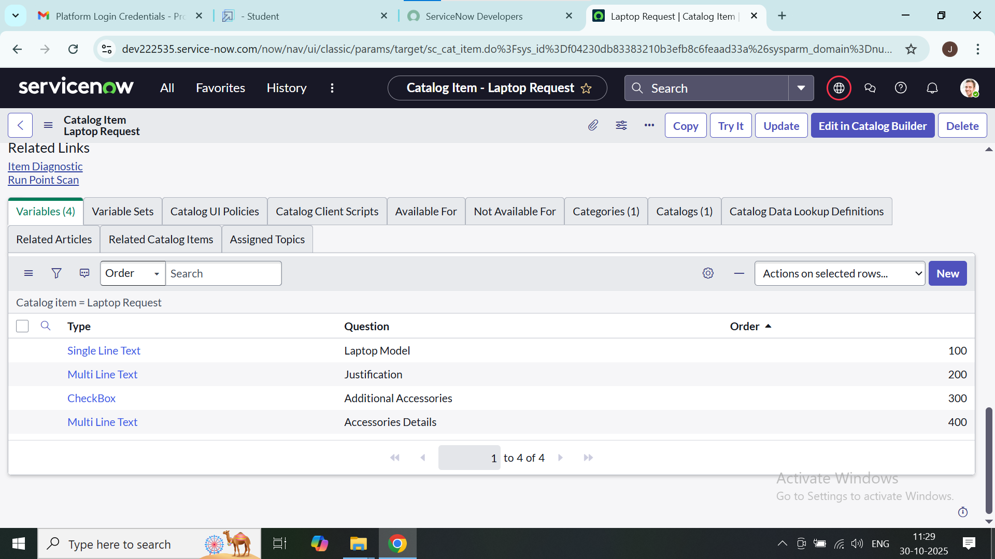

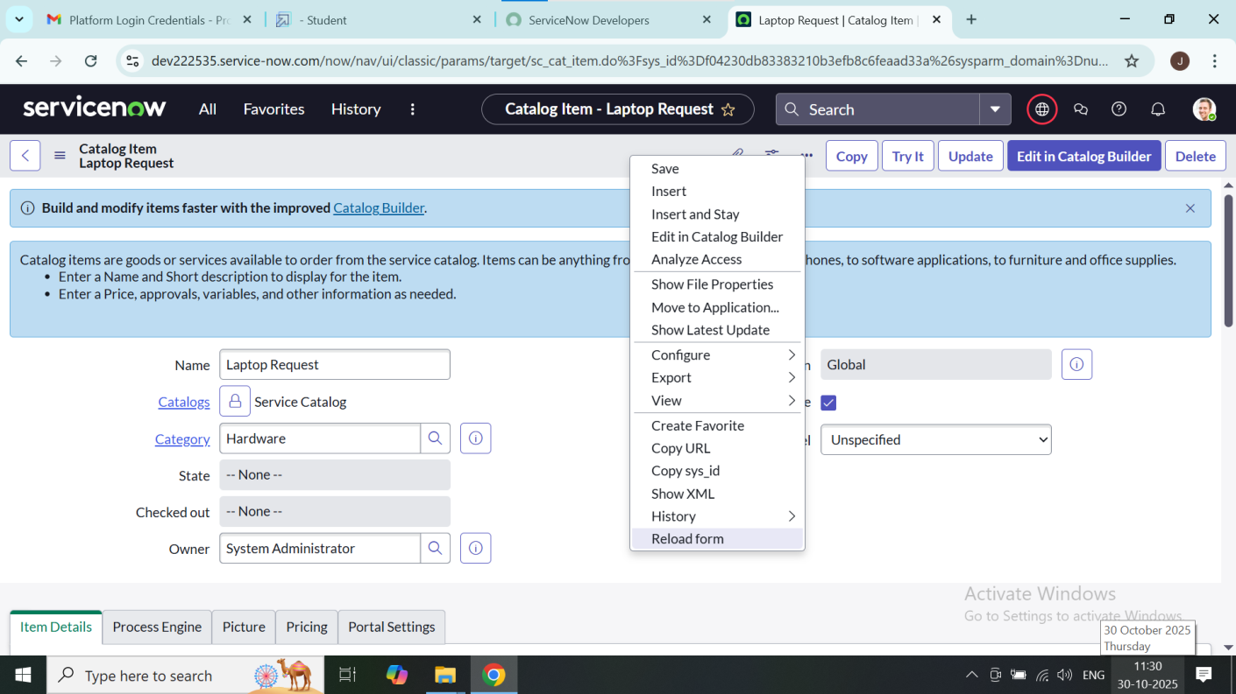

Results and Observations:

• The average response time for submitting a laptop request form was within acceptable limits, ensuring a smooth user experience.

• The system successfully handled multiple concurrent user requests without any major slowdowns or failures.

.

Conclusion:
The Performance Testing of the Laptop Request Catalog Item using ServiceNow successfully verified that the system meets the required performance standards in terms of speed, stability, and scalability. The testing ensured that the catalog item can handle multiple user requests simultaneously without affecting response time or functionality.

